**Website URL: cilproject.iitism.ac.in**

1. **LOGIN**

**a.** login with your username and password (after registering as an user).

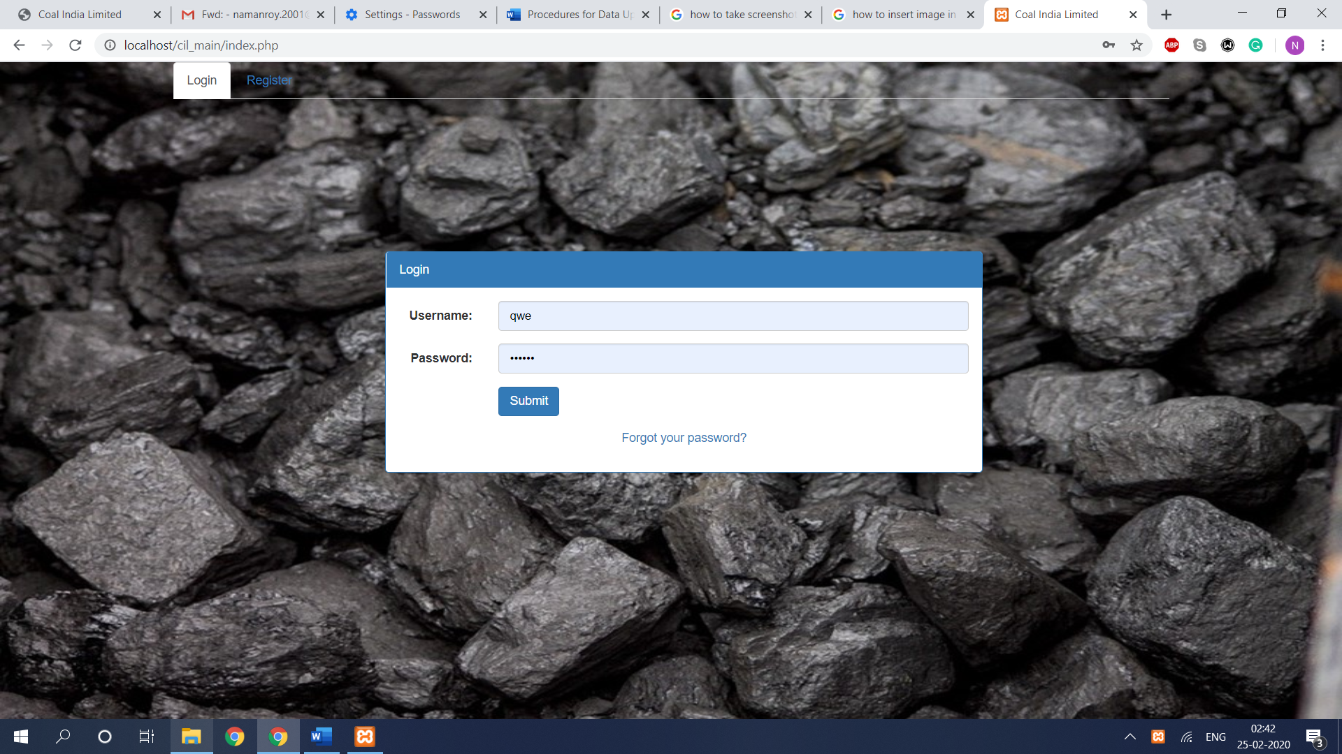

**2. REGISTER (if not have an account)**

**a.** Click on the Register button and fill the corresponding details.

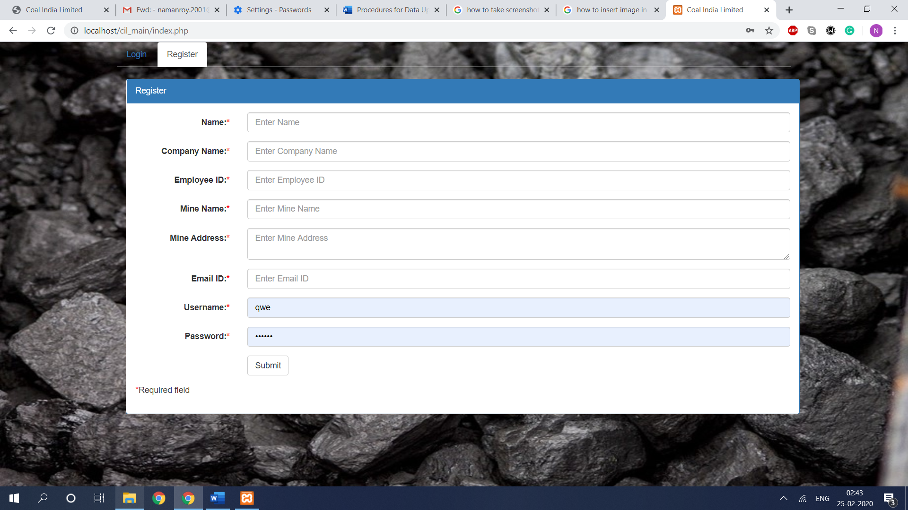

**3.** To upload “**area/subarea/mines/mixed mines**” data for any new subsidiary, first do the following

**a.** Go to “**Menu**” Tab in the header.

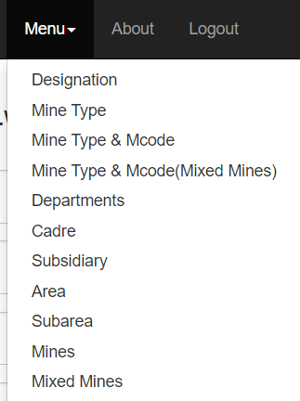

**b.** Select “**Area**” From the dropdown and scroll down till the end of the page.

**c.** Click on “**Choose File**” under “**Select csv file**” header and select the appropriate format area file of the subsidiary and click on the “Import CSV” button.

**d.** Select “**Subarea**” from the dropdown and scroll down till the end of the page.

**e.** Click on “**Choose File**” under “**Select csv file**” header and select the appropriate format subarea file of the subsidiary and click on the “**Import CSV**” button.

**f.** Select “**Mines**” from the dropdown and scroll down till the end of the page.

**g.** Click on “**Choose File**” under “**Select csv file**” header and select the appropriate area file of the subsidiary and click on the “**Import CSV**” button.

**h.** Select “**Mixed Mines**” From the dropdown and scroll down till the end of the page.

**i.** Click on “**Choose File**” under “**Select csv file**” header and select the appropriate area file of the subsidiary and click on the “**Import CSV**” button.

**4.** To upload “**Existing Manpower Data**” for any new subsidiary of a particular year, do the following steps:

**a.** Go to “**Existing Manpower**” Tab in the header.

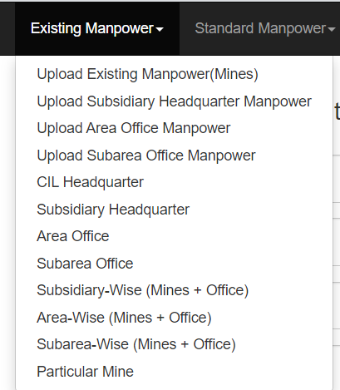

**b.** Click on the “**Upload Existing Manpower (Mines)**” in the the dropdown menu.

1. Select the corresponding subsidiary, then corresponding area, corresponding subarea, choose the mine, and then the mine type.

2. Click on “Choose File” under “Select CSV File” header and choose the appropriate file of existing manpower for that mine and then click on “Import CSV” button.

3. Similarly repeat the steps 1 &2 for all the mines in the subsidiary.

**c.** Select “**Upload Subsidiary Headquarter Manpower**” from the dropdown and scroll down till the end of the page.

**d.** Click on “**Choose File**” under “**Select csv file**” header and select the appropriate format file (.csv extension file) of the subsidiary and click on the “**Import CSV**” button.

**e.** Select “**Upload Area Office Manpower**” from the dropdown and scroll down till the end of the page.

**f.** Click on “**Choose File**” under “**Select csv file**” header and select the appropriate format file (.csv extension file) of the subsidiary and click on the “**Import CSV**” button.

**g.** Select “**Upload Subarea Office Manpower**” from the dropdown and scroll down till the end of the page.

**h.** Click on “**Choose File**” under “**Select csv file**” header and select the appropriate format file (.csv extension file) of the subsidiary and click on the “**Import CSV**” button.

**5.** To upload “**Standard Manpower Data**” for any new subsidiary of a particular year, do the following steps:

**a.** Go to “**Standard Manpower**” Tab in the header.

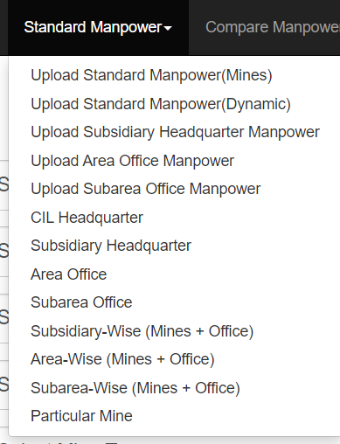

**b.** Click on the “**Upload Standard Manpower (Mines)**” in the the dropdown menu.

1. Select the corresponding subsidiary, then corresponding area, corresponding subarea, choose the mine, and then the mine type.
2. Click on “Choose File” under “Select CSV File” header and choose the appropriate file of standard manpower for that mine and then click on “**Import CSV**” button.
3. Similarly repeat the steps 1 &2 for all the mines in the subsidiary.

**c.** Select “**Upload Subsidiary Headquarter Manpower**” from the dropdown and scroll down till the end of the page.

**d.** Click on “**Choose File**” under “**Select csv file**” header and select the appropriate format file (.csv extension file) of the subsidiary and click on the “**Import CSV**” button.

**e.** Select “**Upload Area Office Manpower**” from the dropdown and scroll down till the end of the page.

**f.** Click on “**Choose File**” under “**Select csv file**” header and select the appropriate format file (.csv extension file)of the subsidiary and click on the “**Import CSV**” button.

**g.** Select “**Upload Subarea Office Manpower**” from the dropdown and scroll down till the end of the page.

**h.** Click on “**Choose File**” under “**Select csv file**” header and select the appropriate format file (.csv extension file)of the subsidiary and click on the “**Import CSV**” button.

**6.** To get existing manpower data of a particular year for any subsidiary, do the following steps:

**a.** Go to “**Existing Manpower**” Tab in the header.



**b.** Click on the “**Particular Mine**” in the dropdown menu to get data of a particular mine

1. Select the corresponding subsidiary, then corresponding area, corresponding subarea, choose the mine, and then the mine type.

2. Click on the **Submit** button.

**c.** Click on the “**Subarea-Wise (Mines+Office)**” in the dropdown menu to get data of a particular subarea.

1. Select the corresponding subsidiary, then corresponding area, corresponding subarea.

2. Click on the **Submit** button.

**d.** Click on the “**Area-Wise (Mines+Office)**” in the dropdown menu to get data of a particular area.

1. Select the corresponding subsidiary, then corresponding area.

2. Click on the **Submit** button.

**e.** Click on the “**Subsidiary-Wise (Mines+Office)**” in the dropdown menu to get data of whole subsidiary.

1. Select the corresponding subsidiary.

2. Click on the **Submit** button.

**f.** Click on the “**Subarea Office**” in the dropdown menu to get data of a particular subarea office.

1. Select the corresponding subsidiary, then corresponding area, corresponding subarea.

2. Click on the **Submit** button.

**g.** Click on the “A**rea Office**” in the dropdown menu to get data of a particular area office.

1. Select the corresponding subsidiary, then corresponding area.

2. Click on the **Submit** button.

**h.** Click on the “**Subsidiary Headquarter**” in the dropdown menu to get data of a subsidiary headquarter.

1. Select the corresponding subsidiary, then corresponding area, corresponding subarea.

2. Click on the **Submit** button.

**7.** To get standard manpower data of a particular year for any subsidiary , do the following steps:

**a.** Go to “**Standard Manpower**” Tab in the header.



**b.** Click on the “**Particular Mine**” in the dropdown menu to get data of a particular mine

1. Select the corresponding subsidiary, then corresponding area, corresponding subarea, choose the mine, and then the mine type.

2. Click on the **Submit** button.

**c.** Click on the “**Subarea-Wise (Mines+Office)**” in the dropdown menu to get data of a particular subarea.

1. Select the corresponding subsidiary, then corresponding area, corresponding subarea.

2. Click on the **Submit** button.

**d.** Click on the “**Area-Wise (Mines+Office)**” in the dropdown menu to get data of a particular area.

1. Select the corresponding subsidiary, then corresponding area.

2. Click on the **Submit** button.

**e.** Click on the “**Subsidiary-Wise (Mines+Office)**” in the dropdown menu to get data of whole subsidiary.

1. Select the corresponding subsidiary.

2. Click on the **Submit** button.

**f.** Click on the “**Subarea Office**” in the dropdown menu to get data of a particular subarea office.

1. Select the corresponding subsidiary, then corresponding area, corresponding subarea.

2. Click on the **Submit** button.

**g.** Click on the “A**rea Office**” in the dropdown menu to get data of a particular area office.

1. Select the corresponding subsidiary, then corresponding area.

2. Click on the **Submit** button.

**h.** Click on the “**Subsidiary Headquarter**” in the dropdown menu to get data of a subsidiary headquarter.

1. Select the corresponding subsidiary, then corresponding area, corresponding subarea.

2. Click on the **Submit** button.

**8.** To get compared manpower data of a particular year for any subsidiary , do the following steps:

**a.** Go to “**Compare Manpower**” Tab in the header.

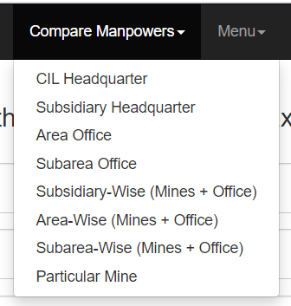

**b.** Click on the “**Particular Mine**” in the dropdown menu to get data of a particular mine

1. Select the corresponding subsidiary, then corresponding area, corresponding subarea, choose the mine, and then the mine type.

2. Click on the **Submit** button.

**c.** Click on the “**Subarea-Wise (Mines+Office)**” in the dropdown menu to get data of a particular subarea.

1. Select the corresponding subsidiary, then corresponding area, corresponding subarea.

2. Click on the **Submit** button.

**d.** Click on the “**Area-Wise (Mines+Office)**” in the dropdown menu to get data of a particular area.

1. Select the corresponding subsidiary, then corresponding area.

2. Click on the **Submit** button.

**e.** Click on the “**Subsidiary-Wise (Mines+Office)**” in the dropdown menu to get data of whole subsidiary.

1. Select the corresponding subsidiary.

2. Click on the **Submit** button.

**f.** Click on the “**Subarea Office**” in the dropdown menu to get data of a particular subarea office.

1. Select the corresponding subsidiary, then corresponding area, corresponding subarea.

2. Click on the **Submit** button.

**g.** Click on the “A**rea Office**” in the dropdown menu to get data of a particular area office.

1. Select the corresponding subsidiary, then corresponding area.

2. Click on the **Submit** button.

**h.** Click on the “**Subsidiary Headquarter**” in the dropdown menu to get data of a subsidiary headquarter.

1. Select the corresponding subsidiary, then corresponding area, corresponding subarea.

2. Click on the **Submit** button.